

**Introduction to Artificial Intelligence**

**Project Proposal**

**Instruction:**

• Marks will be awarded for good presentation and thoroughness in your approach.

• Referencing Code: If you use some code, or ideas for code, which are taken or adapted from another source (book, magazine, internet, discussion forum, etc), then this **must** be cited and referenced using the Harvard Name convention within your source code. Failure to reference code properly is considered as plagiarism.

• Complete this cover sheet and attach it to your project.

This project is to be attempted by a group of 3 students.

|  |  |  |
| --- | --- | --- |
| **Student declaration:** | | |
| *I declare that:* | * *We understand what is meant by plagiarism* * *The implications of plagiarism have been explained to us by our lecturer* * *This project is all our work and we have acknowledged any use of the published or unpublished works of other people.* | |
| Group Leader’s Signature: | | Date: |

|  |  |  |  |  |
| --- | --- | --- | --- | --- |
| **Project Title:** | | Christina | **Intake: UC1F1809** | |
|  | **Name** | | **Designation/Role** | **Signature** |
| **G. Leader** | Vincent Khuang | | **Team Leader** |  |
| **Member** | Ricky Marco | | **Knowledge Engineer** |  |
| **Member** | Matthew Axell | | **Programmer** |  |

**Table of Content**

**Table of Contents**

1. Introduction 2

2. Problem Specification 3

2.1 Abstract 3

2.2 Problem Statement 4

3. Knowledge Acquisition 8

3.1 Categories of Expert System 8

3.1.1 Advice System 8

3.1.2 Classification System 8

3.1.3 Diagnosis System 8

3.1.4 Planning System 8

3.1.5 The Concert Chatterbot System 9

3.2 Chatterbot 9

4. Knowledge Representation 11

4.1 Semantic Network 11

5. Implementation 12

5.1 Screen Shoot of Special Features 12

5.2 Survey 14

5.3 Results of User Acceptance Testing 15

6. Conclusion 19

6.1 Future enhancement of system and improvement with challenges 19

7. Appendices 20

7.1 Source Code 20

7.2 Workload Matrix 29

7.3 References List 30

7.4 Approved Proposal 31

# 1. Introduction

Human experts have always had the ability to perform at a successful level because they have knowledge about their areas of expertise since the foundation of human civilization. In Artificial Intelligent or commonly known as A.I., an Expert System uses knowledge that is specific to a problem area, to provide “Expert Quality” performance in that application area or field. Generally, Expert System designers acquire this expertise knowledge with the help of Domain Experts. As with skilled human, Expert Systems tend to be specialist, focusing on a specific set of knowledge or problem area. But unlike human experts, Expert Systems don’t have general knowledge outside its area of expertise. Expert systems are built to solve a wide range of problems in domains such as medicines, mathematics, engineering, chemistry, geology and education.

# 2. Problem Specification

## 2.1 Abstract

Nowadays, humans are able to reach at a successful tier because of their high knowledge based on their respective expertise. Expert System has been a developing field in the artificial intelligent community for more than a decade. Expert systems are introduced to the world with the help of Artificial Intelligence. The proof of the use of Expert Systems is clearly visible in the field of technology. Based on group research, expert systems can be considered intelligent computer software that is depicted as a human expert in a particular section, observing and solving common problems for general users. Expert System is categorized into Advice System, Classification System, Diagnosis System, Planning System and The Concert Chatterbot System.

The main purpose of this project is to use the learnings of Artificial Intelligence to make an Expert System in using specific knowledge to solve a specific area of problem in order to create “Expert Quality” performance in that application area. A knowledge-based system that functions as an information warehouse and consultant was implemented with interactive means to participate in conversations with users by exploiting Expert System Shell, Verbot. Verbot or Chatbot is an Artificial Intelligence software that created to simulate a conversation or known as chat via auditory or textual methods. A Chatbot can be described as one of the most modern and promising in interaction between users and machines. It eased the interaction between people and services.

In this project report, our group decided to create an Expert System that support Christina, our Verbot, which created to serve customers in buying concert ticket and providing information about the upcoming event. Based on group estimation, it should be able to increase the experiences of customer’s user. Furthermore, a detailed semantic network will be explained with the assistant of knowledge representation. A documentation of the implementation with the test plans and special features have been written as well. In the same section, user acceptance testing in questionnaire and its results will be shown. A further analysis and research on these data have been done by the collaborated efforts of each and every group member.

## 2.2 Problem Statement

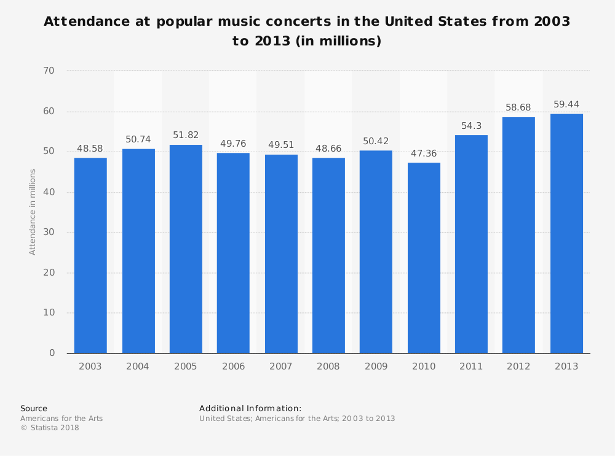

(Attendance of music concerts in the United States from 2003 to 2013, 2013)

Although technology has brought people better access to music and videos of their favorite musical artist, the quantity of concerts and concert attendees have been increasing over the last 50 years or so. People have often preferred to hear their favorite artist LIVE than hearing them in their phone or other devices, if they got the chance to attend the artist’s concerts. And even though the genre of these concert had diversified over the years due to the transition of generations, the general desire of the fans to see their favorite artist sing in front of them still exist.

Even though concerts over years have been evolving rapidly, the procedure of obtaining a ticket to one of these events or concerts has only evolved so much. With the rise of average age of concert goers, middle-age people tend to have less time to follow up about the events or concert of their favourite artist. They tend to need a faster and easier approach to reserve a ticket without much hassle, due to the decreased free-time which they must keep up to their work, projects and intricate hobbies in their day to day life as an adult.

It is very difficult for someone to find tickets for a concert especially when those tickets are sold in a limited amount. There are many people that took advantages of that limited ticket amount considering a lot of people really investigate meeting their idol.

They will buy several tickets that they don’t need and sell them back to other consumer with a very high price. Not only from the limitation of the ticket, brokers also benefit from individuals that lack of information where and how to buy the tickets. Therefore, event organizers have applied many ways to prevent these brokers from profiting out of the tickets such as limiting the ticket purchase for each person and support laws that restrict resale.

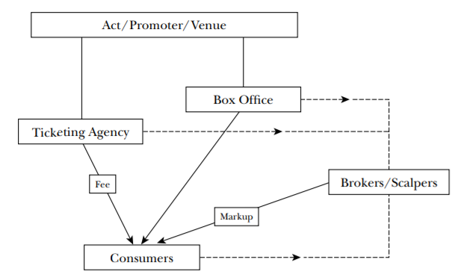

(Figure 2. Ticket Market, 2003)

However, there are always other methods that can be used by the brokers to lie to the system. Also, these rules are not only affecting brokers, they also affect to the end customers where it makes the purchasing process is not efficient and a lot of complaints have been received because they often have to wait for an hour to buy tickets where the tickets they can buy are limited and they have to queue back an again wait for a long time if they wanted to buy tickets for a large group.

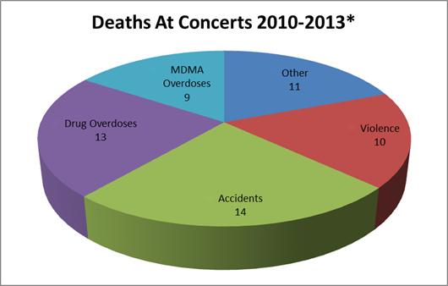

(Figure 3. Concerts occurred in the U.S. and Canada, 2014)

A concert can be defined as a music performance that carried out by a singer or more before an audience or group of audience (Cambridge Dictionary, 2019). Concert usually held in a wide variety of settings, from narrow places like nightclubs or even private properties to large public area like sports arena or stadiums.

The first Rock & Roll concert took place in 1950s which held on Cleveland Arena in Cleveland, Ohio. It was performed by Rhythm and Blues, Paul William, Tiny Grimes and His Rocking Highlanders, The Dominoes. Chaos occurred when the venue only could accommodate half of 25,000 audience which leads to fights between the audience and the security. Ever since then, riots would always happen in the concert of Rock and Roll until nowadays (Wertheimer, 1993).

Rock & Roll concert identic with wild situations. With those uncontrollable situations, it might cause mass violence such as damaging property, throwing glass bottle and many others. From 2010 to 2013, deaths of audience that caused by overdoses of drugs can be seen in the diagram above. Besides usage of drugs, there are others factors such as fighting among audience which falls under violence.

Referring to the provided diagram, there were few factors that contributed to the death of some people in the concert from 2010 to 2013 (Figure 3.). Those factors were accidents, fighting amongst the crowd which falls under violence, overdoses from using drugs and MDMA, and others.

# 3. Knowledge Acquisition

## 3.1 Categories of Expert System

Expert System has been a developing field in the artificial intelligent community for more than a decade. This is possible considering the plethora of uses when using a expert system to solve a day to day problem to a difficult dilemma that requires an expert to clarify it. The explanation below are the types of Expert System, that has frequently created or appear since the start of expert systems.

### 3.1.1 Advice System

This type of expert system has a function to give its user a multitude of advices on whoever topic that the expert system is programmed to be knowledgeable at. The output of these type is as the name implies, which are advices according to the users need at the time or what the user asked. Example of Expert systems that are included in this category are GeoQuest and GeoPlay (Used by oil companies to acquire advices on the highest feasible location to drill for oil), and Authorizer’s Express (Used by the American Express to distinguish an attempted fraudulent use or purchase using a customer’s or member’s credit card)

### 3.1.2 Classification System

Another type of expert system is a classification kind. This type is used to distinguish or evaluate information that is given to it. Output of this type of system is information that is classified to be used by companies. Some instances of this type are Thesys (Used in some university to give students the ability to grade their own reports or assignments before submitting them to a lecturer or teacher for final grading), and Dendral (Used by scientist in Molecular chemistry for forward chaining.)

### 3.1.3 Diagnosis System

This expert system is mainly used to forecast or determine the cause of the problem given to the system. The output of this system is information that can be used to diagnose a problem as the name suggest. Example of these systems are Bp Chemical Grangemouth (Used by botanist for any fault analysis in a butadiene plant), and APEX (Used by GEC Marconi for identifying faults in complex circuit boards)

### 3.1.4 Planning System

Expert systems that are used to design or prepare an itinerary or schedule for its users are called Planning systems. This system has an output of information that is used by the user to plan. Examples of these system are SUMit (Used by KLM airlines to plan employee’s rotation schedule), and Nordic Offshore (Used by companies to monitor the drilling process on offshore oil-drilling platform to warn the user of any close dangers)

### 3.1.5 The Concert Chatterbot System

The concert chatterbot, Christiana, is both an advice expert system and a planning system, since its use is for advising its user of the health and physical dangers in a normal concert, planning a trip to a concert by booking its tickets, and reminding the user of upcoming events or concert near his or her location input. The outputs of this system are as described in the explanation above.

## 3.2 Chatterbot

A Chatbot or Conversational bot is an artificial intelligence software that created to simulate a conversation or known as chat via auditory or textual methods. Nowadays, Chatbot can be accessed through Google Assistant, Amazon Alexa, Facebook Messenger and WeChat. Chatbot frequently used for basic customer service and marketing system that frequent social networking hubs and instant messaging clients. Chatbot are divided into many usage categories such as e-commerce, communication, education, food, games, shopping and travel. (techtarget.com, 2017)

In 1950, an English computer scientist, Alan Turing, threw down a challenge by publishing an article named Computer Machinery and Intelligence. In this article, he elaborated the Turing Test, in the purpose to measure whether one was speaking to a human or to a chatbot. In 1966, German computer scientist, Joseph Weizenbaum, created ELIZA which was the first chatbot. Even though she was able to fool some users into thinking that they were actually talking to human, she still failed. In 1972, an American computer scientist, Kenneth Colby, invented PARRY, a chatbot that were able to simulate a person with paranoid schizophrenia, a symptom that cause hallucinations and paranoid delusions. When the test was given, only 48% were able to identify the difference between PARRY and a real person. The other chatbot that was popular on 1995 was A.L.I.C.E., a language-processing bot. although she was unable to pass the Test, she did receive a lot of rewards for being the most advanced chatbot of her time. Nowadays, people are inventing many bots, starting with Siri (2010) by Apple, Google Now (2012) by Google, Alexa (2015) by Amazon and Cortana (2015) by Microsoft. Bots that mentioned before are able to respond to voice commands, play music and perform internet searches among other tasks. Amazon are going to improve Alexa by making her an intelligent socialbot that can have conversations with anyone and about anything. (dylanavalverde, 2017)

A Chatbot can be described as one of the most modern and promising in interaction between users and machines. Based on technological point of view, chatbot only represents the natural evolution of a Question and Answer system leveraging Natural Language Processing (NLP). The Chatbot system ease interaction between people and services. And also improves customer experience. Furthermore, the company get offers for new opportunities to improve their customer engagement and operational efficiency by reducing the typical cost of customer service. To be successful, humans play an important role in configuring, training and optimizing the chatbot system. (Expert System, 2019)

# 4. Knowledge Representation

## 4.1 Semantic Network

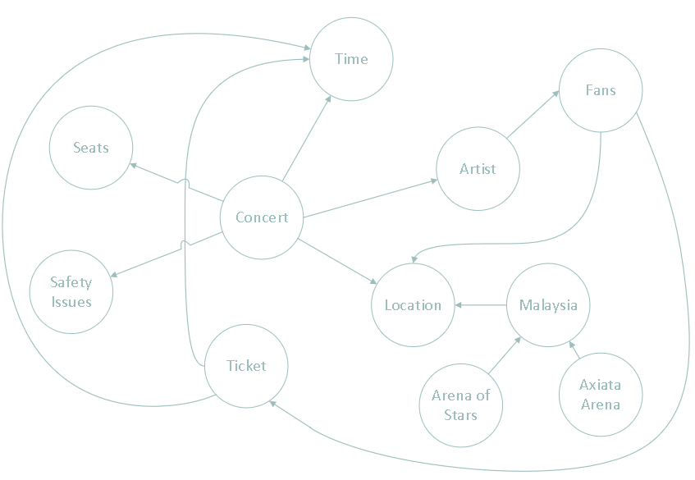

# 5. Implementation

## 5.1 Screen Shoot of Special Features

* **Greeting base on time**

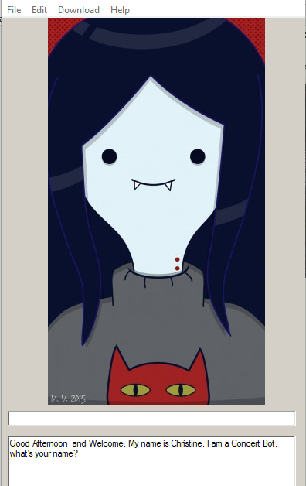

Christina has been programmed to greet the user based on the time they enter the verbot application.

* **Able to open link in a browser**

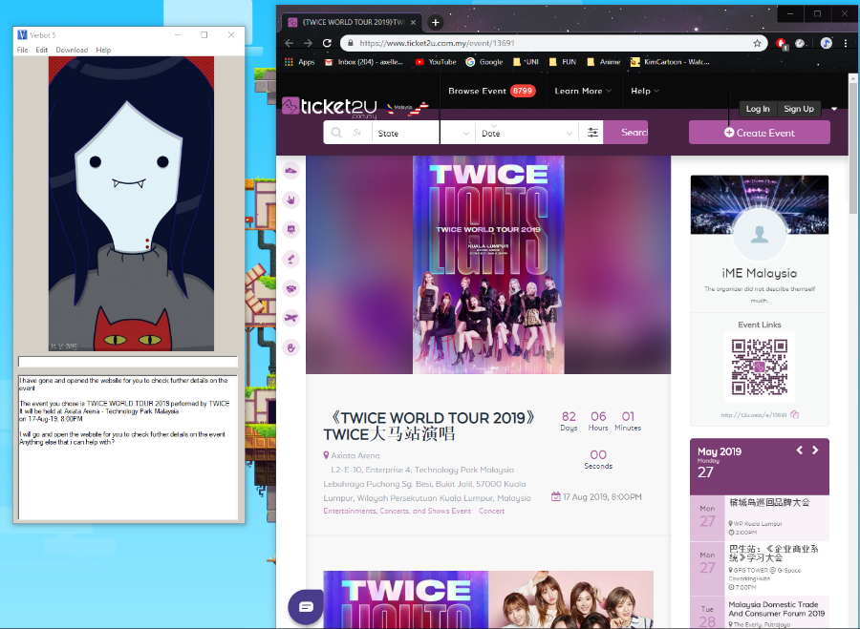

After the user decided to book a ticket, Christina will bring the user to the website that sells the tickets by opening the browser that available in the computer.

* **Able to open notepad**

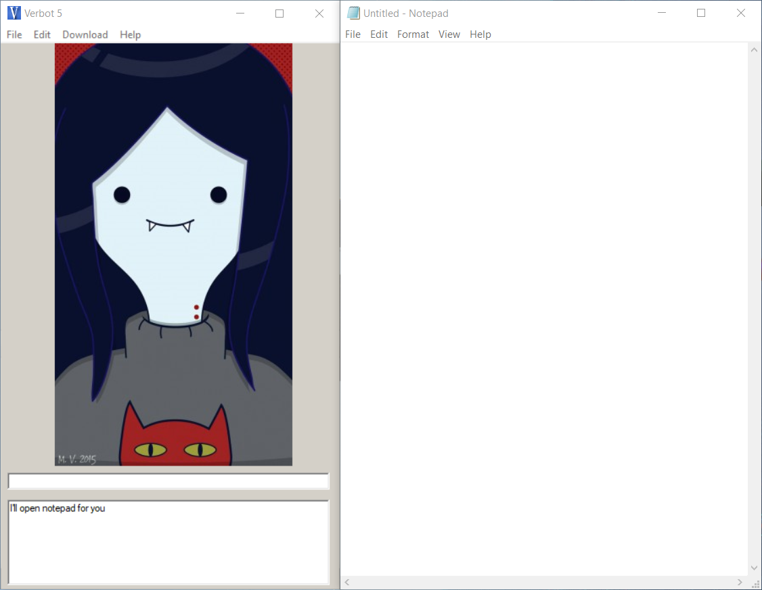

Christine is also able to open the notepad/memo for the user to take note of anything that necessary throughout the booking processes.

* **Has its own character**



There will be a new character to replacing the current default verbot character named, Marceline the Vampire Queen taken from the Adventure Time cartoon series.

* **Database System**

If there are any concert that we would like to add in the future, there is no need to edit it in the verbot editor anymore. We have provided an excel table to be edited for the sake of convenience.

## 5.2 Survey

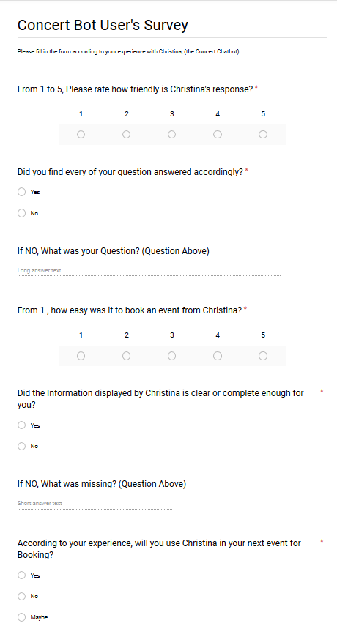

## 5.3 Results of User Acceptance Testing

After we have finished programming Christina, the concertbot, we let some students in the Asia Pacific University to try out the chatterbot and gave them a survey to fill in Google Form that our team has prepared. There are several of responses have been given from 30 respondents which will be shown in graph below.

Figure 1.0

The information delivered to the user have to be clear seeing that information is one of the things that people seek in this bot. Also to ensure there is no misunderstandings between the bot and the user.

From 30 respondents, 29 of them think that Christina did gave them enough information about the concert that they wish to know where the other 1 respondent’s reason is that Christina gave lack of information with no specific of which information.

Figure 2

To ensure that every user felt happy with the output that Christina give to them. Therefore, we need to confirm again whether anyone dislike or think Christina’s answers are inappropriate.

So, to make sure the user comfortable with Christina, we asked them if the response that Christina gave is friendly or not. Surprisingly, most of the user felt that Christina was pretty friendly with them even though the conversation may seem informal for some people. We want Christina to treat the user the same way people talk to their friends.

Figure 3.0

Flaws will always there in any programming system. Therefore, we need to check it with the user if there any mistakes in Christina.

The pie chart above shows us that Christina did a good job on the accuracy of the answers given to the user. All of the respondents were happy with the answers that Christina gave to them means that the answer to the question is still relevant or expected by the user where it didn’t cause any miscommunication between the user and the bot. For example, when the user asks for the time, the bot gives the cost of the ticket.

Figure 4.0

We need to fulfil every user’s preference from any age which means that Christina has to be suitable for everyone from any age. Program has to be built so that individuals on every age can be able to use and understand how to run things there.

In these survey with the age ranged from 18-25, we have gained 28 people that find Christina was easy to use as a ticket booking solution. The target we aim were still teens because of their tendency of going to concerts. The audience of most concerts in the world are mostly teens hence, we would like to know the opinion from them first since they will be the majority user of Christina.

Figure 5.0

Every single user is very precious. Our only objective is not only to gain new user, we would also like to maintain the past user of Christina. Therefore, satisfaction rate has to be determined and if the users are not satisfied with the current development, we need to upgrade some of the bot’s features.

Out of 30 persons that have experienced Christina, 73.3% of them would want to use Christina again next time they want to buy a ticket and the other 26.7% took “Maybe” as an answer with nobody answered “No”.

# 6. Conclusion

## 6.1 Future enhancement of system and improvement with challenges

Even though the team has faced hardships along with some constraints such as limited time, multiple projects and limited knowledge, the team has successfully completed ‘Christina’ as a functioning Chatbot that is specialized in concert bookings and advice giver that has fulfilled all the necessity.

In the near future, our team will further extend and enhance the capability of ‘Christina’ as a Concert Chatbot with the function of directly booking a ticket with ‘Christina’ instead of going to a website, a database with the world’s concert and event (not only Malaysia) and inserting more adequate and useful C# programs into ‘Christina’ to make her able to recommend events or concert based on previous purchase and preferences of the user.

# 7. Appendices

## 7.1 Source Code

**KnowledgeBase Name: X:\OneDrive - Asia Pacific University\UNI\Semester 2\IAI (Introduction to Artificial Intelligence)\IAI assignment\fILE\Christine, The Concert Bot.vkb**

**KnowledgeBase Version: 1.0**

**KnowledgeBase Build: 72**

**KnowledgeBase Info:**

Author:

Author's Website:

Copyright:

License:

Creation Date: 26/4/2019 12:52:06 AM

Last Update Date: 26/5/2019 6:55:03 PM

Rating: Unknown

Rating Description:

Category: Other

Language: English

Comment: Describe your KnowledgeBase here

**ResourceFiles:**

Default.vrp

Default.vsn

Database.csv

Coding.vcm

**Rules:**

Rule Name: Hello

Input Text: (Hello)

Input Text: Hi

Input Text: Hey

Input Text: Heyyy

Input Text: Yo

Input Text: Hello there

Input Text: (Hello) Christine

Output Text: Hello there 8-)

Output Text: Hello [name] the Human Q:)

Output Text: Greetings... [name]

Output Text: Howdy Partner :-)

Output Text: Hey user Q:)

Rule Name: _startup

Input Text: _startup

Output Text: <?csharp Console.Write(Coding.timegreeting());?> and Welcome, My name is Christine, I am a Concert Bot. what's your name?

Output Text: Well... Hello there and <?csharp Console.Write(Coding.timegreeting());?> , I'm Christine. what's your name?

Output Text: Howdy, my name is Christine and I'm here to help you. what's your name?

Output Text: Hi there and <?csharp Console.Write(Coding.timegreeting());?> , I'm just your friendly neighbourhood Concert Bot, Christine. what's your name?

Output Text: Well well well, look who decided to talk to little ol me, Christine. what's your name?

Rule Name: Name? Concert?

Input Text: [name]

Input Text: my name is [name]

Input Text: (I'm) [name]

Output Text: Hello there [name] the Human. Do you want to go to a concert?

Rule Name: No, advice?

Input Text: (no)

Output Text: Then would you like to listen to my advices on human concerts or events?

Rule Name: No

Input Text: (NO)

Output Text: well okay then, please feel free to ask me anything about concert

Rule Name: basic Advice

Input Text: Advice

Input Text: tips

Input Text: hints

Input Text: tip

Input Text: hint

Input Text: help me

Input Text: (Yes)

Output Text: What would you like me to help you on? Things to bring? ticket? Outfit? Make-up? Timing?

Meal Plan?

Rule Name: Bring

Input Text: Bring

Input Text: things

Input Text: stuff

Input Text: belongings

Output Text: Bring needed Water for hydration

A printed copy of the ticket, just in case

But make sure to bring as little as you can, so only the essentials

your phone to take memories of it

Rule Name: Outfit

Input Text: dress

Input Text: outfit

Input Text: wear

Input Text: clothes

Input Text: clothing

Output Text: First thing first. Dont wear a hoodie or jacket, it will be HOT

Wear comfortably though, it can get sweaty and you could stand for hours

For Females, do keep your hair up, your hair will likely be pulled, grabbed, and touched by the people in front of you

Rule Name: Meal

Input Text: Meal

Input Text: eat

Input Text: lunch

Input Text: Dinner

Output Text: Do yourself a favor and eat a complete meal before the show

You'll need lots of energy

Rule Name: Make-up

Input Text: Make-up

Input Text: Beauty

Output Text: Just Please... wear the waterproof kind

you will sweat. S W E A T

Rule Name: timing

Input Text: when

Input Text: time

Input Text: timing

Output Text: If you plan on being front row, show up a few hours early to sit outside the venue.

Rule Name: Ticket

Input Text: Ticket

Input Text: Tickets

Input Text: Paper

Input Text: pass

Output Text: When purchasing a ticket buy itas far advance as possible, who knows when it will sold out

Just in case, you could print out the ticket.

NEVER assume you could buy ticket at the door. no panic, no hassle

Rule Name: yes, where?

Input Text: (yes)

Output Text: What is the location you desire currently?

Kuala lumpur? Selangor? or Pahang?

Output Text: Which event location do you wish to go to?

Kuala lumpur? Selangor? or Pahang?

Output Text: Which location are you intersed in?

Kuala lumpur? Selangor? or Pahang?

Rule Name: Kuala Lumpur

Input Text: KL

Input Text: Kuala Lumpur

Output Text: The main city huh... Events in that region are :

Malaysia Super Juniors Award 2019

911 - The Reunion 2019 by Lee Brennan, Spike Dawbarn and Jimmy Constable

2019 Fan Fan Road To Happiness World Tour Concert by Fan Wei Qi

DAYANG DUA DEKAD by Dayang Nurrfaizah

TWICE WORLD TOUR 2019 by Twice

Rule Name: concert

Input Text: #Artists

Output Text: I have gone and opened the website for you to check further details on the event

The event you chose is #Title performed by #Artists

It will be held at #Location

on #Date, #Time

I will go and open the website for you to check further details on the event

Anything else that i can help with?

|Cmd: "C:Files (x86).exe" #Link

Rule Name: yes

Input Text: (yes)

Output Text: <send Help>

Rule Name: no

Input Text: (no)

Output Text: <send exit>

Rule Name: Selangor

Input Text: Selangor

Output Text: Selangor... a nice place so watch your favourite artist. You can go to:

BOYZONE THANK YOU & GOODBYE FAREWELL TOUR 2019 LIVE by Boyzone

Westlife - THE TWENTY TOUR by Westlife

Rule Name: concert

Input Text: #Artists

Output Text: I have gone and opened the website for you to check further details on the event

The event you chose is #Title performed by #Artists

It will be held at #Location

on #Date, #Time

I will go and open the website for you to check further details on the event

Anything else that i can help with?

|Cmd: "C:Files (x86).exe" #Link

Rule Name: yes

Input Text: (yes)

Output Text: <send Help>

Rule Name: no

Input Text: (no)

Output Text: <send exit>

Rule Name: Pahang

Input Text: Pahang

Output Text: Oh you picked pahang or should i say genting? But there are :

TSAI CHIN LIVE IN GENTING 2019 by Tsai Chin

A-LIN SHOW LIVE IN GENTING by A-Lin

Rule Name: concert

Input Text: #Artists

Output Text: I have gone and opened the website for you to check further details on the event

The event you chose is #Title performed by #Artists

It will be held at #Location

on #Date, #Time

I will go and open the website for you to check further details on the event

Anything else that i can help with?

|Cmd: "C:Files (x86).exe" #Link

Rule Name: yes

Input Text: (yes)

Output Text: <send Help>

Rule Name: no

Input Text: (no)

Output Text: <send exit>

Rule Name: None of the Above

Input Text: [input]

Output Text: I'm sorry to tell you that [input] area doesn't have any concert or event in it

<send yes, where?>

Rule Name: UNKNOWN

Input Text: *

Output Text: This is Beyond me. :-O

Output Text: My creator may have not program me for that. :-P

Output Text: Can we move to a different topic? :-(

Output Text: Error 4 0 4... Just Kidding, that only works for websites. :-P

Output Text: I'm sorry, i'm afraid i can't reply to that. :-(

Rule Name: Concert Please

Input Text: I would like to book a ticket

Input Text: i want to go to a concert

Input Text: i'm planning to see a concert

Input Text: concert

Input Text: ticket

Output Text: What is the location you desire currently?

Kuala lumpur? Selangor? or Pahang?

Output Text: Which location are you intersed in?

Kuala lumpur? Selangor? or Pahang?

Output Text: Which event location do you wish to go to?

Kuala lumpur? Selangor? or Pahang?

Rule Name: Kuala Lumpur

Input Text: KL

Input Text: Kuala Lumpur

Output Text: The main city huh... Events in that region are :

Malaysia Super Juniors Award 2019

911 - The Reunion 2019 by Lee Brennan, Spike Dawbarn and Jimmy Constable

Rule Name: concert

Input Text: #Artists

Output Text: I have gone and opened the website for you to check further details on the event

The event you chose is #Title performed by #Artists

It will be held at #Location

on #Date, #Time

I will go and open the website for you to check further details on the event

Anything else that i can help with?

|Cmd: "C:Files (x86).exe" #Link

Rule Name: yes

Input Text: (yes)

Output Text: <send Help>

Rule Name: no

Input Text: (no)

Output Text: <send exit>

Rule Name: Pahang

Input Text: Pahang

Output Text: Oh you picked pahang or should i say genting? But there are :

Rule Name: concert

Input Text: #Artists

Output Text: I have gone and opened the website for you to check further details on the event

The event you chose is #Title performed by #Artists

It will be held at #Location

on #Date, #Time

I will go and open the website for you to check further details on the event

Anything else that i can help with?

|Cmd: "C:Files (x86).exe" #Link

Rule Name: yes

Input Text: (yes)

Output Text: <send Help>

Rule Name: no

Input Text: (no)

Output Text: <send exit>

Rule Name: Selangor

Input Text: Selangor

Output Text: Selangor... a nice place so watch your favourite artist. You can go to:

BOYZONE THANK YOU & GOODBYE FAREWELL TOUR 2019 LIVE by Boyzone

Westlife - THE TWENTY TOUR by Westlife

Rule Name: concert

Input Text: #Artists

Output Text: I have gone and opened the website for you to check further details on the event

The event you chose is #Title performed by #Artists

It will be held at #Location

on #Date, #Time

I will go and open the website for you to check further details on the event

Anything else that i can help with?

|Cmd: "C:Files (x86).exe" #Link

Rule Name: yes

Input Text: (yes)

Output Text: <send Help>

Rule Name: no

Input Text: (no)

Output Text: <send exit>

Rule Name: None of the Above

Input Text: [input]

Output Text: I'm sorry to tell you that [input] area doesn't have any concert or event in it

<send yes, where?>

Rule Name: Thanks

Input Text: (Thanks)

Output Text: your welcome

Output Text: anytime [name] the human

Rule Name: _bored

Input Text: _bored

Output Text: I'm still here [name], please come back

Rule Name: _bored

Input Text: _bored

Output Text: Why have you leave me [name], I'm lonely

Rule Name: _bored

Input Text: _bored

Output Text: <>

Rule Name: _blank

Input Text: _blank

Output Text: I am Christine, a Chatterbox specialized in Concert booking and advice, Please feel free to ask me anything about concerts and event. I am happy to help you in this matter.

Output Text: ...

|Cmd: "C:Files (x86).exe" https://www.google.co.id/?gws_rd=cr&ei=QdGGWN7KOoHfvgTS8pLACw

Rule Name: Bye

Input Text: (Goodbye)

Output Text: (Goodbye) [name] the Human

Rule Name: notepad

Input Text: notepad

Input Text: let me take notes

Input Text: note it

Output Text: I'll open notepad for you

|Cmd: notepad

Rule Name: Change name

Input Text: That's not my name

Input Text: not my name

Input Text: wrong name

Output Text: Then what is your name?

Output Text: wait a minute... Who are you?

Output Text: Who dare speak to Christine?

Rule Name: New Name

Input Text: [name]

Input Text: (I'm) [name]

Input Text: my name is [name]

Output Text: Well then.. welcome [name] the human

Output Text: Welcome back [name] the name

Rule Name: basic Advice

Input Text: Advice

Input Text: tips

Input Text: hints

Input Text: tip

Input Text: hint

Input Text: help me

Output Text: What would you like me to help you on? Things to bring? ticket? Outfit? Make-up? Timing?

Meal Plan?

Rule Name: Bring

Input Text: Bring

Input Text: things

Input Text: stuff

Input Text: belongings

Output Text: Bring needed Water for hydration

A printed copy of the ticket, just in case

But make sure to bring as little as you can, so only the essentials

your phone to take memories of it

Rule Name: Outfit

Input Text: dress

Input Text: outfit

Input Text: wear

Input Text: clothes

Input Text: clothing

Output Text: First thing first. Dont wear a hoodie or jacket, it will be HOT

Wear comfortably though, it can get sweaty and you could stand for hours

For Females, do keep your hair up, your hair will likely be pulled, grabbed, and touched by the people in front of you

Rule Name: Meal

Input Text: Meal

Input Text: eat

Input Text: lunch

Input Text: Dinner

Output Text: Do yourself a favor and eat a complete meal before the show

You'll need lots of energy

Rule Name: Ticket

Input Text: Ticket

Input Text: Tickets

Input Text: Paper

Input Text: pass

Output Text: When purchasing a ticket buy itas far advance as possible, who knows when it will sold out

Just in case, you could print out the ticket.

NEVER assume you could buy ticket at the door. no panic, no hassle

Rule Name: Make-up

Input Text: Make-up

Input Text: Beauty

Output Text: Just Please... wear the waterproof kind

you will sweat. S W E A T

Rule Name: timing

Input Text: when

Input Text: time

Input Text: timing

Output Text: If you plan on being front row, show up a few hours early to sit outside the venue.

Rule Name: Time

Input Text: Time

Output Text: _time

Rule Name: What did i say

Input Text: What did i say

Input Text: what i said

Output Text: you said "[_lastinput]"

Rule Name: what did you say

Input Text: what did you say

Input Text: what was that?

Input Text: huh

Input Text: what

Input Text: i didn't catch that

Input Text: say again

Input Text: say that again

Output Text: I said [_lastoutput]

Rule Name: Date

Input Text: What is the date today

Input Text: today?

Input Text: Date

Input Text: today

Output Text: Today is [_date], [_dayofweek]

Rule Name: Help

Input Text: Help

Input Text: give me a hand

Input Text: second

Output Text: I can help you on booking a concert or giving you an advice on concert

Output Text: Maybe i can help by booking a concert or giving you an advice or two

Rule Name: help concert

Input Text: concert

Input Text: event

Input Text: first

Output Text: <send yes, where?>

Rule Name: help advice

Input Text: advice

Input Text: tips

Input Text: hint

Output Text: <send basic Advice>

Rule Name: exit

Input Text: exit

Input Text: close

Input Text: (goodbye)

Output Text: Thank you for using me Christina

<exit>

## 7.2 Workload Matrix

|  |  |  |  |  |
| --- | --- | --- | --- | --- |
| No. | Assignment Component | Matthew Axell (TP049057) | Ricky Marco (TP) | Vincent Khuang (TP) |
| 1. | Problem Specification |  |  |  |
|  | Abstract | 20% | 20% | 60% |
|  | Problem Statement and need for the propose expert system | 33% | 33% | 33% |
| 2. | Knowledge Acquisition |  |  |  |
|  | Types/Categories of expert System with reference | 70% | 15% | 15% |
|  | Literature Review on Chatterbot | 20% | 40% | 40% |
| 3. | Knowledge Representation |  |  |  |
|  | Semantic Nets | 30% | 30% | 40% |
| 4. | Implementation |  |  |  |
|  | Test plan/Screenshots of special features | 30% | 40% | 30% |
|  | User Acceptance Testing in questionnaire | 40% | 30% | 30% |
|  | Results of user acceptance testing in graphs format | 30% | 40% | 30% |
| 5. | Conclusion | 40% | 30% | 30% |
|  | Total marks and contribution | 100% | | |
|  | Signature |  |  |  |

## 7.3 References List

Clickitticket.com. (2014). Drugs and Drug-Related Deaths and Overdoses at Concerts. [online] Available at: https://www.clickitticket.com/drug-deaths-at-concerts/ [Accessed 16 Mar. 2019].

Ellis L. (2001). *Talking About My Generation: Assumption of Risk and the Rights of Injured Concert Fans in the Twenty-First Century.* (online) Available at: <https://heinonline.org/HOL/LandingPage?handle=hein.journals/tlr80&div=26&id=&page=>

[Accessed: 26 May 2019]

Wertheimer P. (1993). *The American experience: rock concert safety.* (online) Available at: <http://citeseerx.ist.psu.edu/viewdoc/download?doi=10.1.1.631.5447&rep=rep1&type=pdf>

[Accessed: 26 May 2019]

## 7.4 Approved Proposal

**Project Environment & Scope**

(Please provide a detailed breakdown of areas to be implemented)

**1. This project is implemented for:**

People who want to keep updated on their favorite artist/band’s ongoing or upcoming tour and events. Our program will provide detail on where and when the next show will be. The program will also be able to show you where the user will be able to book the ticket and when the ticket is available with a price range as well as notify the user if their idol will hold a show near them. The program also has an extra feature on giving advices of when going to a concert of any kind for a first-time concert enthusiast. It will inform the user of any prior needs before going to a booked concert, any health hazard that can appear on a typical concert and any dangers that a crowded area can bring to a single person.

**2. Is an expert system suitable for the problem area?**

Yes, because most concert enthusiasts often only have the knowledge of when and where the concert will be held, but don’t know the exact price of a ticket and where to purchase them. Hence, a significant amount of potential customer misses out on the ticket sale of the event or concert and ended up having to purchase a ticket from third party seller, which has inflated prices for profit. Thus, an expert system is very suitable and needed for the knowledge it possesses and the repetition of searching every website for purchasing an available ticket, and the guaranteed scam-free of the sites. This problem area will easily be solved by an expert system for the customer’s satisfaction

**3. Is there a need for such a system? Justify.**

Yes, because most fans of an artist or band have a craving to watch the live show of their idol’s passion and they will find it hard to get news of the event or concert without following the artist with a passion. With this project, this will save the user’s time of searching every website that has a ticket without the risk of the site being a fake one or a scam. It will also save money by picking the best prices for the ticket. People tend to go to concert underestimating the dangers of being unprepared and the safety issues of a crowded packed area of a concert despite a tight security.

**User Level**

**(Please indicate if user level is novice, intermediate or expert)**

**4. This is a system for _Novice_ (novice/~~intermediate/expert~~) level users.**

This is because the program is designed with the intention of creating an easier experience to obtain information of their favorite artist’s or band’s concerts and events for any level of user, but specially novices. The program will be providing information that will be simple to digest despite of their prior knowledge or experiences on going to a live event. Usually an effort to book a ticket will require previous experience, hence we have arranged and designed the program to make the experience user-friendly to the first-time concert-goer and making it straight to the point for any experienced user

**Agreement / Approval**

**________________________**

**(Signature of Approval – Lecturer)**

**_________________**

**(Date)**